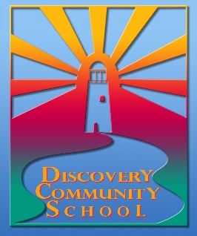
Discovery Community School
12801 84th Avenue NE
Kirkland, WA 98034

[Date]

To whom it may concern:

Add the following newly elected officers to the BECU account #3588945897 and #3588945897 for the Community Group of Discovery School:

[Name of Incoming Co-Chair] – Vice-President
[Name of Incoming Treasurer] –Co-Treasurer

Regards,

[Name of Second Year Co-Chair for upcoming Year]
President 20[ ]-20[ ]
Community Group of Discovery Community School

